Optimization of Frequency Parameters Choice in the Polarization Analysis of Transport Noise

Oksana Kopylova
Geophysical informatics laboratory
Institute of Computational Mathematics and Mathematical Geophysics SB RAS
Novosibirsk, Russia
okkplv@yandex.ru
Vladimir Dobrorodny
Geophysical informatics laboratory
Institute of Computational Mathematics and Mathematical Geophysics SB RAS
Novosibirsk, Russia
vovan2172@mail.ru
Marat Khairetdinov
Geophysical informatics laboratory
Institute of Computational Mathematics and Mathematical Geophysics SB RAS,
Novosibirsk state technical university
Novosibirsk, Russia
marat@opg.sscc.ru

Abstract—One of the passive geophysical monitoring tasks for transport noise moving sources is to determine their location against a background noise at current time moments using three-component registration. The polarization processing method with preliminary signal filtering in informative frequency bands is considered. The orientation of the polarization-processed scattering ellipse allows us to determine the azimuthal direction to the source. The azimuthal error arising here is due to external noise from the environment. One of the methods to reduce it is to use preliminary filtering of useful oscillations in the informative frequency bands. The optimization problem of preliminary band-pass filtering parameter choice to increase the accuracy of direction finding is considered. Numerical estimates of the accuracy of solving the problem under field experiment conditions are obtained. It is shown that the use of band-pass filtering can significantly increase the accuracy of determining the direction to the source, which becomes more noticeable with increasing distance to it.
Key words—traffic noise, polarization analysis, bandpass filtering, location accuracy, passive geophysical monitoring, field experiments.

Introduction
The problem of geophysical monitoring of ambient man-made noise due to the increase in the number of cars and the development of production is becoming increasingly important. The main task here is to identify sources of noise, in particular, to determine the direction to the source. In the case of using small seismic groups (SSG), a polarization analysis method based on three-component registration of seismic oscillations from a source in a rectangular coordinate system X, Y, Z can be used for this [1, 2]. This method allows to determine the vector direction of arrival of oscillations from the source [3]. This method relates to the use of wave polarisation and is a general method of seismic research [4, 5]. Oscillations generated by transport are described by harmonic functions with variable parameters against the background of broadband noise. In this case, the three-dimensional vector of seismic oscillations describes an ellipsoid of revolution along trajectories scattered in the space, "scattering ellipsoid". The measured polarization characteristics of seismoacoustic waves are used as an informative parameter to determine the azimuthal direction to the noise source.
The paper deals with the problem of increasing the accuracy of determining the direction to the source of seismic oscillations when using the method of polarization analysis. To solve this problem, it is proposed to use preliminary band-pass filtering based on the selection of the main frequency parameters characterizing the radiation sources. Based on the results of field experiments, estimates of the increase in location accuracy are given depending on the selected frequency band.

Problem Statement
To calculate the coordinates of the source, you need to know two components: the distance from the registration point and the azimuth.
The polarization method consists in finding the direction of wave propagation and is based on data on the change in the trajectory of particle motion in time. The position of the particle on the trajectory at each moment of time can be characterized by different parameters depending on the selected coordinate system. In a rectangular coordinate system, these are the projections of A_{x}, A_{y}, A_{z} of the full oscillation vector A on the x, y, z axes. If the positive x-axis is aligned with the north direction, the y-axis with the east, and the z-axis toward the zenith, then
$A_{x}\left(t\right)=\left|A\left(t\right)\right|\sin{φ\left(t\right)\cos{ω\left(t\right),}}$
$A_{y}\left(t\right)=\left|A\left(t\right)\right|\sin{φ\left(t\right)\sin{ω\left(t\right)}{,}}$ (1)
$A_{z}\left(t\right)=\left|A\left(t\right)\right|\cos{φ\left(t\right)}$
where |A(t)| - the magnitude of the vector A or displacement at the moment t; ω(t) is the azimuth of the direction of the oscillation; φ(t) is the angle between the vector A and the vertical line at each moment of time [4].
In a sliding time window, the dimensions of which are selected depending on the wavelength, trace noise and sampling step, the amplitude of the main component of the particle displacement in the wave is calculated from the records of the three-component receiver. For each position of the time window, a covariance matrix is calculated [6].
Measurement data is represented as a set of points, or radius vectors ${\vec{x}}_{i}≡\left(x_{i},y_{i},z_{i}\right)$. The task is to determine the direction given by the unit polarization vector $\vec{p}≡\left(p_{x},p_{y},p_{z}\right)$ such that the sum of the squared distances of all points from the straight line drawn in this direction is minimal. The eigenvalues and eigenvectors of the covariance matrix of the input data are determined from the equation[6, 7]:
$\left(\begin{matrix}\sum{x_{i}^{2}} & \sum{x_{i}y_{i}} & \sum{x_{i}z_{i}} \\ \sum{x_{i}y_{i}} & \sum{y_{i}^{2}} & \sum{y_{i}z_{i}} \\ \sum{x_{i}z_{i}} & \sum{y_{i}z_{i}} & \sum{z_{i}^{2}}\end{matrix}\right)\left(\begin{matrix}p_{x} \\ p_{y} \\ p_{z}\end{matrix}\right)=λ\left(\begin{matrix}p_{x} \\ p_{y} \\ p_{z}\end{matrix}\right),$ (2)
The polarization vector determined from (2) is the eigenvector ${\vec{p}}_{1}$ of the covariance matrix corresponding to the maximum eigenvalue.
The other two eigenvectors, ${\vec{p}}_{2}$ and ${\vec{p}}_{3}$, give two orthogonal directions.
The eigenvalues 𝜆₁≥𝜆₂≥𝜆₃ show the value of the deviation of polarization from linear.
Knowing the parameters of the axes of the instantaneous polarization ellipsoid, one can find the tangential and azimuthal angles, as well as the ellipticity coefficient, which characterizes the "elongation" of the polarization ellipsoid.
The direction of the main axis of the polarization ellipsoid is determined from the components of the vector ${\vec{p}}_{1}$.
The azimuth angle is found from the expression:
$Φ=arctan\left(\frac{p_{1y}}{p_{1x}}\right)$, (3)
where p_{1𝑥}, p_{1𝑦} – 𝑥 and y are the components of p₁, respectively.
The tangential angle is calculated by the formula:
$Θ= arctan\left(\frac{\sqrt{p_{1x}^{2}+p_{1y}^{2}}}{p_{1z}}\right)$, (4)
where p_{1𝑥}, p_{1𝑦}, p_{1z} – 𝑥, y and z are components of p₁, respectively.
The ellipticity coefficient is calculated by the formula:
$e=\sqrt{\frac{3λ_{3}}{λ_{1}+λ_{2}+λ_{3}}}$ (5)

Solution of the Problem
To improve the accuracy of determining the direction to the source of oscillations, it is necessary to first solve the problem of noise suppression and extraction of useful signals. This can be done using a digital filtering procedure based on the Butterworth filter. This filter is characterized by the most flat frequency response in the passband and monotonic in the stopband. The considered filter can be described by the equation:
$K\left(ω\right)=\frac{1}{\sqrt{1+{\left(\frac{ω}{ω_{0}}\right)}^{2n}}},$ (6)
where ω₀ is the cutoff frequency, n is the filter order.
Filtration limits can be determined empirically using data from field experiments. Within the framework of this approach, experimental work was carried out related to the registration of seismic oscillations from tracked vehicles.

Work Procedure
In the course of the work, records of seismic oscillations generated by tracked vehicles were obtained experimentally.
Oscillations were recorded at distances of 111 and 237 m from the source. The scheme of the experiment is shown in Fig. 1. The Figure shows the locations of the recorders, as well as the points corresponding to the location of the source. Signals were recorded using a GS-3 three-component sensor.
The azimuth of the sensor installation was 353°. For the first point, the azimuth of the north direction is 6°, for the second - 273°. Thus, the angle between the direction of the X component of the sensor and the first point is - 13°, the angle between the direction of the X component of the sensor and the second point is 80°.

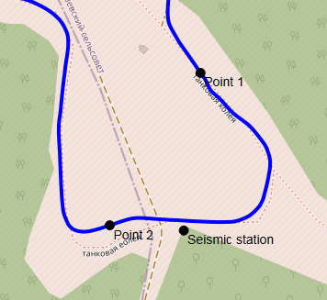
Fig. 1. Scheme of the experiment

Experimental Results
In the course of the work, a spectral analysis of the transport noise records obtained during the experiment was carried out. This analysis showed that for tracked vehicles the most characteristic is the oscillation frequency of about 17 Hz, which can be seen from Fig. 2-3.

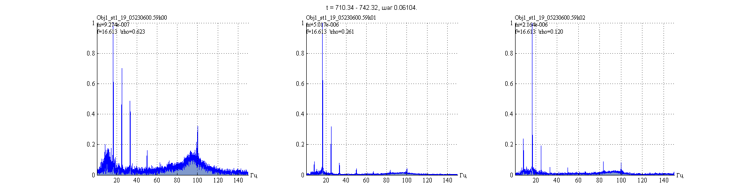Fig. 2. Graphs of spectral analysis of signal records recorded during the operation of tracked vehicles at a distance of about 111 m.

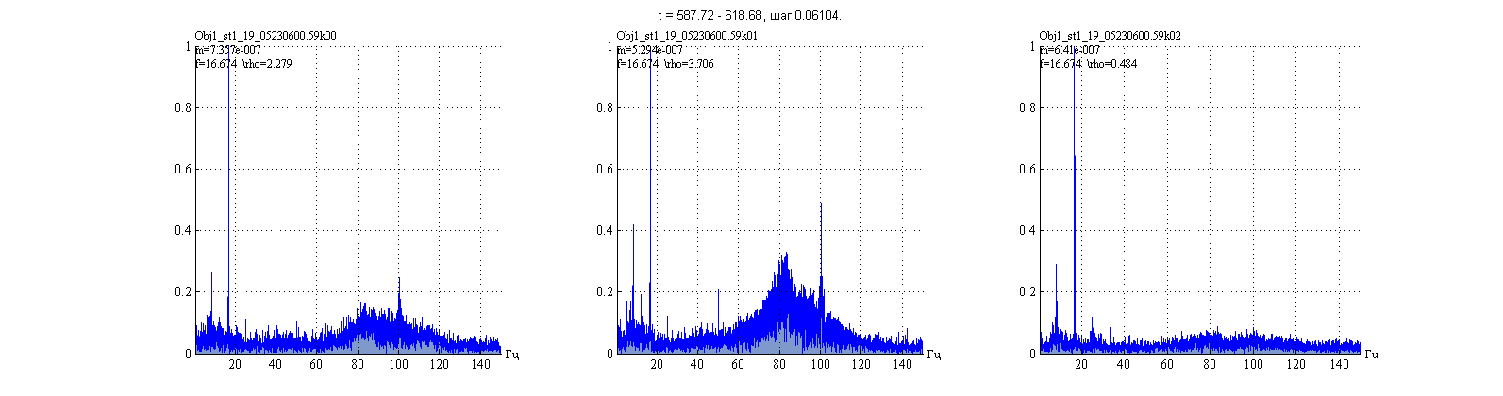
Fig. 3. Graphs of spectral analysis of signal records recorded during the operation of tracked vehicles at a distance of about 237 m.

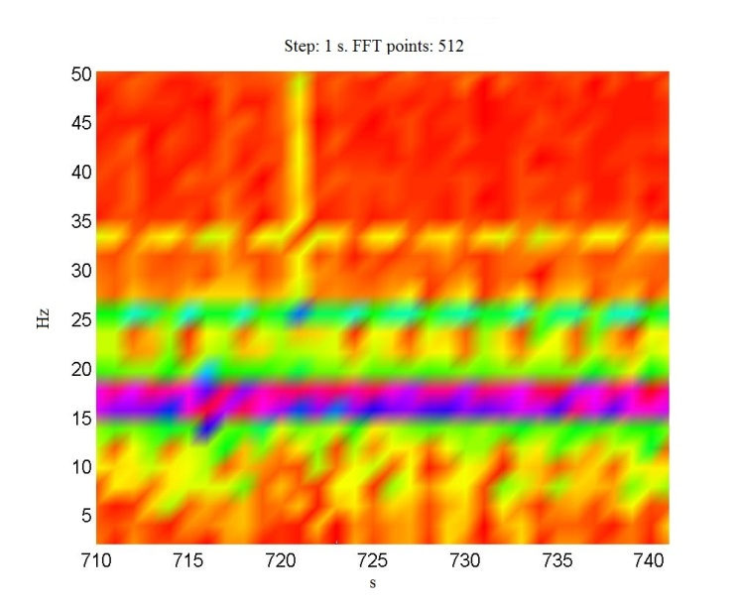Fig 4. Spectral-time analysis. The distance to the source is about 111 m.

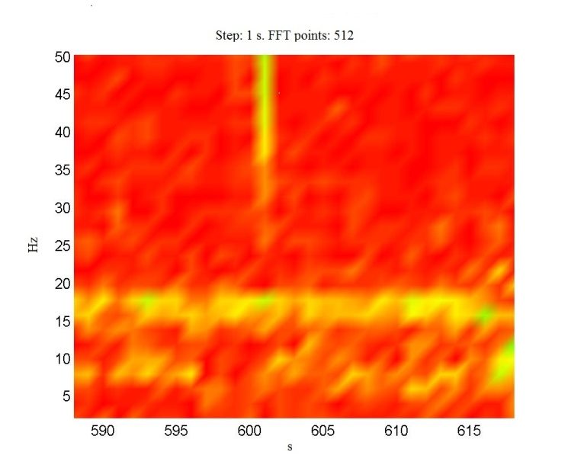 Fig 5. Spectral-time analysis. The distance to the source is about 237 m.

To show the dynamics of the frequency spectrum over time, a spectral-time analysis is used. As an example, graphs of spectral-time analysis of noise arising from the operation of tracked transport are presented in Figures 4, 5. It can be seen from the plots that constancy of the allocated dominant frequencies is maintained throughout the whole recording interval. At a closer distance – 111 m – subharmonics at frequencies around 8-9, 25-26 and 34-35 Hz are visible in addition to the main frequency. At 237 m the high frequencies are attenuated and lower frequencies, 8-10 Hz, are clearly visible (Figure 5).
It follows that the choice of informative frequencies must be linked to distance.
Based on the data obtained, the corresponding frequency regions were selected for band-pass filtering.
In accordance with (5), the values of the ellipticity coefficients were obtained for the azimuthal plane XY and for the vertical planes YZ and XZ. The ellipticity coefficients were calculated for the data obtained at a distance of about 111 m from the source in Fig. 6 and at a distance of about 237 m from the source of Fig. 7.
It can be seen from the graphs that preliminary filtering in the 12-21 Hz frequency band for the source under consideration can significantly reduce the coefficient of ellipticity of the polarization ellipse. Further narrowing of the frequency band affects the change in the coefficient of ellipticity insignificantly. With a further expansion of the filtration band, a significant increase occurs in the ellipticity coefficient Fig. 7. At a greater distance, the effect of filtering in the selected frequency band has a more significant effect on reducing the ellipticity coefficient, and, consequently, on increasing the accuracy of determining the direction to the source.
In accordance with (3), the values of the polarization angles were obtained for the azimuthal plane XY and for the vertical planes YZ and XZ. The polarization angles obtained at a distance of about 111 m to the source are shown in
Fig. 8. The values of the polarization angles obtained at a distance of about 237 m to the source are shown in Fig. 9.
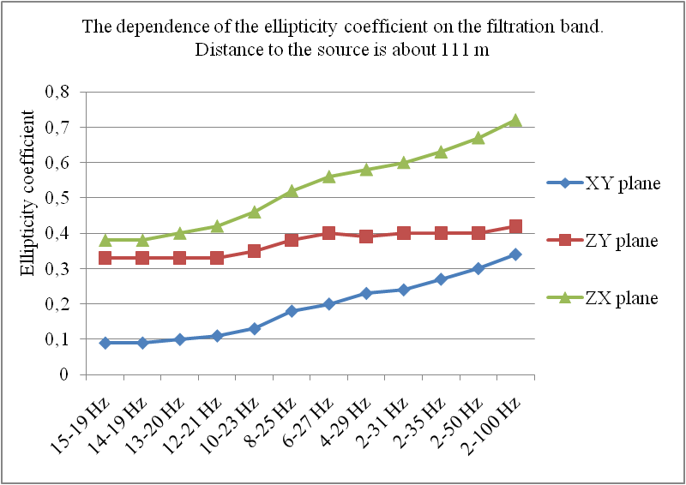Fig 6. Graph of the dependence of the ellipticity coefficient on the filtration band. The distance to the source is about 111 m.

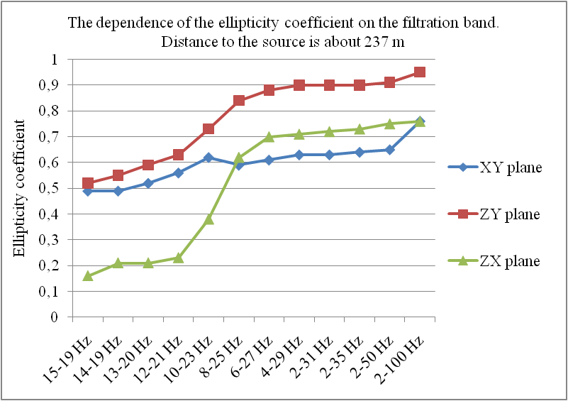Fig. 7. Graph of the dependence of the ellipticity coefficient on the filtration band. Distance to the source is about 237 m.

As an example, the Fig. 10 shows polarograms of oscillation records recorded at a distance of about 111 m, obtained after filtering in a frequency band of 12-21 Hz meters from the source. Figure 11 shows polarograms of the oscillation recordings filtered at the same frequencies but at a distance of about 237 meters. These figures clearly show how the distance from the oscillation source to the seismic receiver affects the shape of the polarization ellipse. It can be seen that increasing the distance leads to increasing the ellipticity coefficient (5), i.e. the blurring of the scattering ellipse.
Based on the results of the polarization analysis with preliminary filtering in the 12-21 Hz frequency band, it was determined that the angle between the direction of the X component of the sensor and the first point is - 24.7°, the angle between the direction of the X component of the sensor and the second point is 80°. For comparison, if it is to filter in the frequency band from 2 to 50 Hz, then it is determined that for the first point the angle is - 26.8°, for the second is 79.4°.
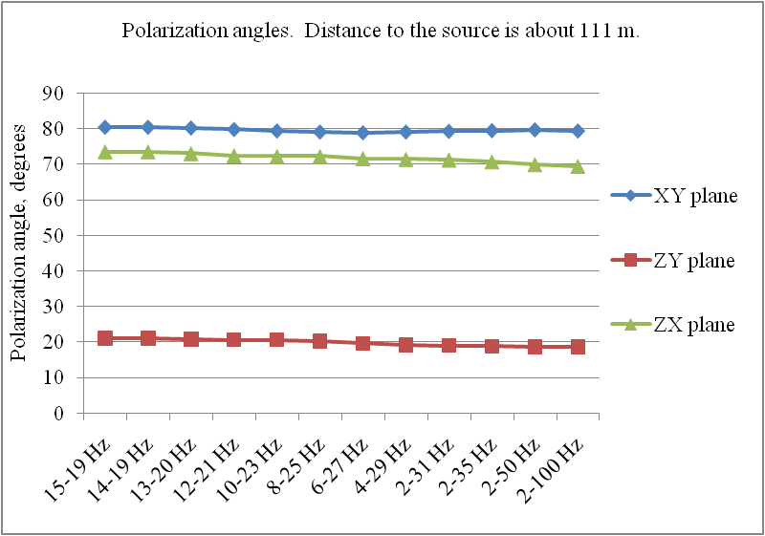Fig. 8. Polarization angles. The distance to the source is about 111 m.

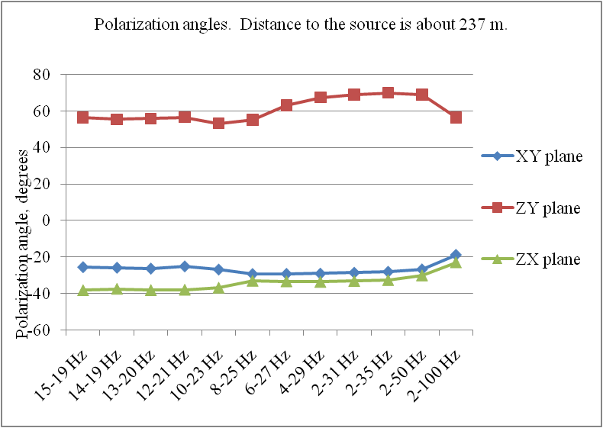
Fig. 9. Polarization angles. The distance to the source is about 237 m.

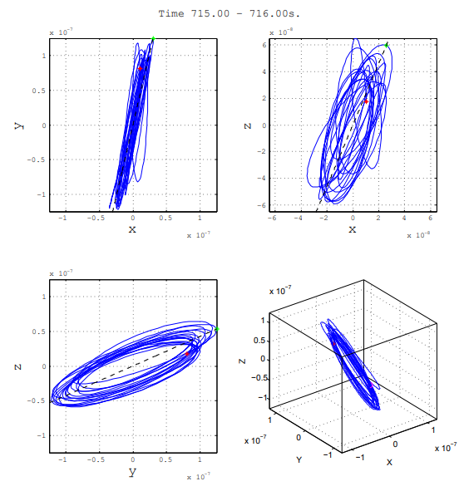
Fig. 10. Polarograms obtained after filtering in the 12-21 Hz frequency band. The distance to the source is about 111 m.
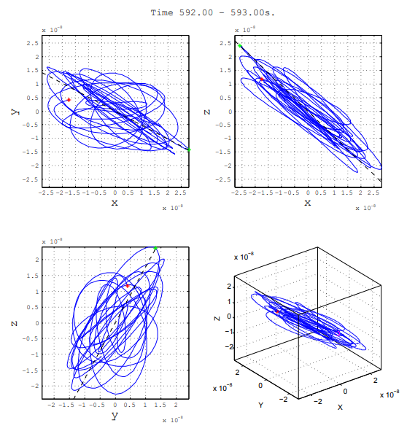
Fig. 11. Polarograms obtained after filtering in the 12-21 Hz frequency band. The distance to the source is about 237 m.
Thus, it can be seen that the use of band-pass filtering makes it possible to increase the accuracy of determining the direction to the source, which becomes more noticeable with an increase in the distance to the source.

Conclusion
The paper presents the consideration of task of increasing the accuracy of location of the source of seismic oscillations in conditions of small seismic groups. To solve the problem of determining the direction to the source, the method of polarization analysis is considered. To improve the measurement accuracy, the preliminary bandpass filtering method is proposed and used. In this connection an approach is considered to optimize the choice of the frequency characteristics of transport noise. Numerical estimates of the accuracy of solving the problem are obtained depending on the selected frequency band of filtering of experimental data. It is shown that the use of band-pass filtering makes to increase the accuracy of determining the direction to the source. That becomes more noticeable with an increase of the distance to the source.
Acknowledgment
This work was supported by RFBR (grants №№ 18-47-540006р_а, 20-07-00861А)

References
- I.I. Gurvich, G.N.Boganik. Seismic exploration: Textbook for universities. - 3rd ed., Rev. - M .: Nedra, 1980, 551 p.
- Alessandrini B, Cattaneo M, Demartin M, Gasperini M, Lanza V. A simple P-wave polarization analysis: its application to earthquake location. Annals of Geophysics 5(5). 1994. pp. 883-897
- Azik I. Perelberg, Scott C. Hornbostel; Applications of seismic polarization analysis. Geophysics 1994; 59 (1): 119–130
- E.I. Galperin, Polarization method of seismic research. M., "Nedra", 1977. 277 p.
- E.I. Galperin, L.I. Ivanov, U.D. Mirzoyan, Polarization method - General method of seismic exploration. – Oil and gas geology and geophysics. Ref. scientific and technical collection of VNIIOENG, №9,1978, pp. 38-43.
- A. P. Grigoryuk, V. V. Kovalevsky, L. P. Braginskaya. Investigation of the polarization of seismic waves during vibroseismic monitoring // Interexpo GEO-Siberia. XIV Int. scientific congress, April 23–27, 2018, Novosibirsk: Int. scientific conference. "Remote sensing methods of the Earth and photogrammetry, environmental monitoring, geoecology": collection of articles. materials in 2 volumes. Novosibirsk: SSUG&T, 2018. V.2. p. 10-16.
- D. Kahaner, C. Moler, S. Nash. Numerical methods and software: Trans. from English. - Ed. second, the stereotype. - M .: Mir, 2001, 575 p.

